**CHAPTER-1**

INTRODUCTION to project

**INTRODUCTION TO PROJECT**

* 1. **Introduction:**

The Online Movie Ticket Booking project in Java is a software application that provides a convenient way for users to book movie tickets online. This project aims to streamline the ticket booking process, making it easier and more efficient for both users and theatre owners.

The project allows users to browse through a list of available movies, view their details such as title, genre, cast, and show timings. Users can select their preferred movie and choose a showtime that suits them. The application provides real-time information on seat availability and lets users select their desired seats from a seating layout.

User Registration Users can create an account by registering with their personal details. The mechanism ensures secure access to the web-site and personal information. Movie Listings The project provides a comprehensive list of movies currently playing in theatre. Users can view details such as movie title, cast, and launch. Seat Selection Users can choose their preferred seats from a seating layout displayed for each movie show. Once users have selected their movie and seats, they can proceed to book tickets. The project integrates with a dummy payment gateway to facilitate for payments

After successful payment, users receive a booking confirmation with details such as movie title, showtime, seat numbers, and a unique booking reference number. Users can access their booking history to view past and upcoming movie bookings. This feature allows users to keep track of their movie preferences and previous transactions.

The project includes an admin panel that allows owners or administrators to manage movie listings, update show timings, monitor bookings, and view sales reports. The Online Movie Ticket Booking project in Java provides a user-friendly and efficient platform for booking movie tickets online. It simplifies the ticket booking process, reduces waiting time, and enhances the overall movie-going experience for users. Whether it's selecting seats, making payments, or managing bookings, this project offers a comprehensive solution for both users and theatre owners.

**1.2 Existing System:**

The existing system for the Online Movie Ticket Booking project primarily involves manual ticket booking processes, both online and offline. It typically consists of physical ticket counters at movie theaters where customers have to visit in person to purchase tickets. Alternatively, some theatre may offer phone-based bookings or bookings through third-party websites.

Customers have to physically visit the theatre to purchase movie tickets. They stand in queues, sometimes for extended periods, to buy tickets for their desired showtimes. This process is time-consuming and inconvenient, especially during peak hours or for popular movie releases

**1.3 Need of Computerization:**

Computerization of the Online Movie Ticket Booking System brings several benefits and improvements over the existing manual processes. Here are some key reasons highlighting the need for computerization Computerization system generates number of anytime with required format

Secure Online Payments: Computerization facilitates secure online payment options, allowing customers to make payments using various methods such as credit/debit cards, net banking, or digital wallets. Integration with secure payment gateways ensures the confidentiality and integrity of financial transactions, providing a safe and convenient payment experience for users.

1. Improved Accessibility
2. Enhanced User Experience
3. Efficient Seat Selection
4. Booking History and Personalization.

**1.4 Scope of Study:**

The scope of study for the Online Movie Ticket Booking System project documentation encompasses various aspects related to the development and implementation of the system. It outlines the boundaries and objectives of the project, along with the specific areas that will be covered. Here are the key areas within the scope of study younger consumers were more likely to have used online movie ticket booking system essentially adoption on service approaches.

Outline the architectural design and components of the online movie ticket booking system. This involves defining the system's modules, their functionalities, and their interactions. Document the database design, user interface design, and integration of external services such as payment gateways. Research and select the appropriate technologies and frameworks for implementing the online movie ticket booking system. Consider programming languages (such as Java), frameworks (such as Spring Boot or any other preferred framework), databases (such as MySQL or any other relational database management system), and other supporting tools.

Create wireframes or mockups of the user interface to visually represent the different screens and user flows within the application. Document the design principles, user experience considerations, and any usability testing conducted to ensure an intuitive and user-friendly interface.

Design the database schema to store information related to movies, theatre, show timings, seat availability, user details, booking history, and any other relevant data. Document the database tables, relationships, and data access mechanisms. Explain the process of implementing the online movie ticket booking system. This includes developing the backend logic, creating APIs for communication between the frontend and backend, integrating payment gateways, implementing security measures, and handling system scalability.

Document the testing methodologies and techniques used to ensure the quality and reliability of the system. This includes unit testing, integration testing, and system testing. Document any test cases, test plans, and test results to validate the system's functionality and performance. A customer will search for a favorite Movie on Web-site location, choose from available movies. Payment can be amongst others either by credit card or cash, upi etc.

**CHAPTER-2**

Proposed system

**PROPOSED SYSTEM**

**2.1 Proposed System:**

This system is a bunch of benefits from various points of view. This online application enables the end-users to register to the system online, select the movie of their choice from the homepage, and book the movie Also, the payment can be made through online mode or at the time of movie suitable for the all customer’s convenience.

the Online Movie Ticket Booking project aims to replace the existing manual processes with an automated and user-friendly online platform. The system will offer a comprehensive set of features to enhance the ticket booking experience for users and streamline the operations for theatre owners. Here are the key aspects of the proposed system:

With this web-application, Users will have the option to create an account by registering with their personal details. The system will ensure secure authentication to protect user information and restrict unauthorized access. Users will be able to visually select their desired seats from a seating layout displayed for each movie show. The system will dynamically update seat availability in real-time, allowing users to choose from the available seats. The ticket prices for different seats or sections of the theatre can be configured and displayed to users during the booking process.

The system will implement robust security measures to protect user data and financial transactions. It will adhere to industry standards for data encryption, secure communication protocols, and secure coding practices to ensure the privacy and integrity of user information.This system allows the to customers within less time as compared to the manual system.

**2.2 Objective of System:**

The objectives of this study is as follows:

* To evaluate the way of interaction with customers.
* To develop a movie ticket booking system with web application based on

the client server application.

* To determine the factors that influence customer when booking a ticket online.
* To computerized the movie ticket booking system process and display details of sales history.

**2.3 Feasibility study:**

The feasibility study is useful to evaluate the cost and benefits of the system. The feasibility study tries to anticipate future scenario of web development. There are three measure aspects as:

1. Technical feasibility study
2. Operational feasibility study
3. Economical feasibility study

**1.Technical feasibility study:**

Technical feasibility study is always focuses on existing hardware and software. This also includes the need for more hardware and software and possibility of installing such a facility.

**2. Operational feasibility study:**

The operational feasibility study is related to what exactly or which exactly operations are performed. It considers the acceptability of the system. It checks whether system is used if it is developing and able to handle the system.

**3. Economical feasibility study:**

The economical feasibility considers the cost or benefits or proposed system. The benefits are always accepted to over waiting cost, developments cost, investment cost, salaries and maintenance.

**2.4 Fact Finding Techniques:**

**DEFINITAION: -**

The specific methods used for collecting data are called fact finding techniques.

During developing the system under consideration following methodology are used.

1. The existing manual system was carefully studied with its drawbacks and limitations.
2. After taking interviews of concern theatre staff members, a requirement of system was noted.
3. The various forms are collected and studied.
4. Useful suggestions were taken.
5. Prepared necessary documents and programs required.
6. Programs was debugged and tested with test data.
7. Integration of whole system to achieve the coordination is done.

**2.5 System Requirements:**

**Hardware And Software Hardware Requirements**

The system requirements divided into two categories Hardware and Software requirement are as follows:

**Hardware Requirements:**

1. Processor **:** Intel(R) p4,2.66 Ghz Ht. 2MB Cache

2. RAM **:** 1 GB

3. Hard disk **:** 40 GB Har disk (7200 RPM)

4. Input Device **:** Keyboard, Mouse.

5. Output Device **:** Monitor, Printer.

**Software Requirements:**

1. Operating System**:** Windows –10

2. IDE**:** Netbeans 7.2

3. Front-End Tool**:** Java Script, Html, Css

4. Back-End Tool**:** MYSQL, Java

5. Reports**:** Jasper Report

**CHAPTER-3**

System design

**SYSTEM DESIGN**

**3.1 Zero Level Diagram**

**USER**

**ADMIN**

Register and Login Login

Select Movie View add Movie

Bill Bill View Scehdule

P Payment Bookings

Logout View Registration

* 1. **DFD :-Data flow Diagram**

Login

**Admin**

Add Movie

Time & Date

**Update**

Bookings

Send message

Select seats

Cancel Tickets

Payments

**User**

Bookings

Payment

Report

User

list

Movie

List

Report’s

* 1. **DFD:-Data flow Diagram**

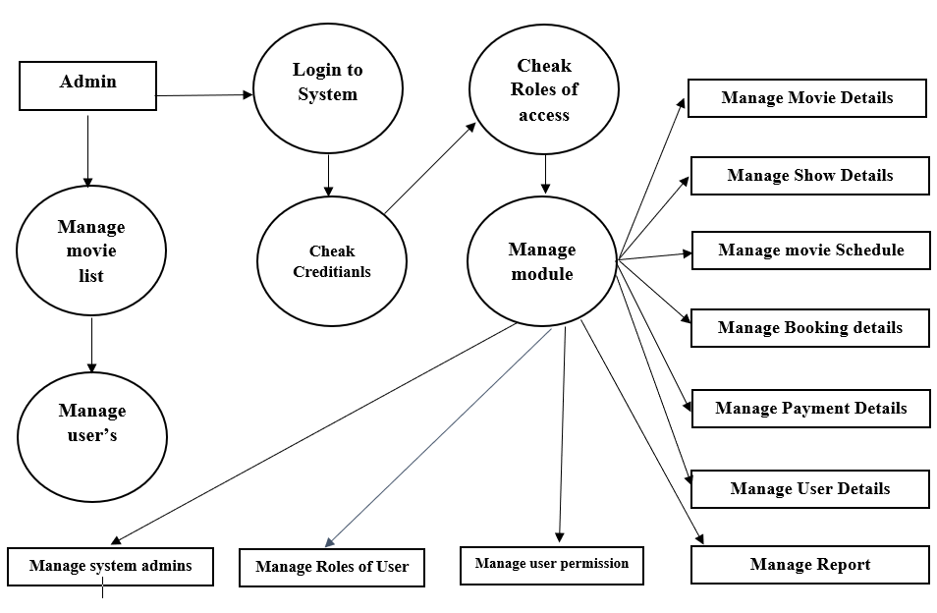

**3.3 E-R Diagram:**

**Gives**

Payment

**Makes**

Customer

Cust Booking

**Contains**

**Has**

Movie Category

Movie

Bookings

**Has**

Online Movie ticket Booking

**Manage**

Admin

**Database Design**

**3.4 Database design:**

**Database name:** (With extension)

**1. Register:**

|  |  |
| --- | --- |
| **Field Name** | **Data Type** |
| Register Id | Int |
| First Name | nvarchar(50) |
| Last Name | nvarchar(50) |
| Phone No | nvarchar(50) |
| Email Id | nvarchar(50) |
| Password | nvarchar(50) |
| Confirm Password | nvarchar(50) |

**2.User Profile:**

|  |  |
| --- | --- |
| **Field Name** | **Data Type** |
| Id | Int |
| Name | nvarchar(50) |
| Surname | nvarchar(50) |
| Phone No | nvarchar(50) |
| Email Id | nvarchar(50) |

**3. Seat Booking:**

|  |  |
| --- | --- |
| **Field Name** | **Data Type** |
| Booking Id | Int |
| User Id | Int |
| User Name | nvarchar(50) |
| Movie Name | nvarchar(50) |
| Time | nvarchar(50) |
| date | Date |
| Seat No | Int |

**4. Payment Page:**

|  |  |
| --- | --- |
| **Field Name** | **Data Type** |
| Id | Int |
| Name | nvarchar(50) |
| Phone No | nvarchar(50) |
| Amount | nvarchar(50) |
| Payment Method | nvarchar(50) |
| Payment No | nvarchar(50) |

**5.Feedback page:**

|  |  |
| --- | --- |
| **Field Name** | **Data Type** |
| Id | Int |
| User Id | Int |
| User Name | nvarchar(50) |
| Description | nvarchar(200) |

**6.Admin Registration:**

|  |  |
| --- | --- |
| **Field Name** | **Data Type** |
| Id | Int |
| First Name | nvarchar(50) |
| Last Name | nvarchar(50) |
| Phone No | Big Int |
| Email Id | nvarchar(50) |
| Password | nvarchar(50) |
| Confirm Password | nvarchar(50) |

**7.Add Movie:**

|  |  |
| --- | --- |
| **Field Name** | **Data Type** |
| Id | Int |
| Movie Name | nvarchar(50) |
| Casting | nvarchar(50) |
| Release Date | nvarchar(50) |
| Info | nvarchar(50) |

**CHAPTER-4**

User manual

**USER MANUAL**

The main menu of the system is as follows:

When you run this system the password program is run password:

When the password screen display on the screen. If the password is incorrect then” login is failed” error is displayed.

**Main Menu**

**Logout**

**Bookings**

**Master**

**Home**

Login Movies Seats

Register My bookings Time

Feedback Date

Profile

**CHAPTER-5**

Input output screens

**INPUT OUTPUT SCREENS**

**Input Output Screen: -**

**Home: -**

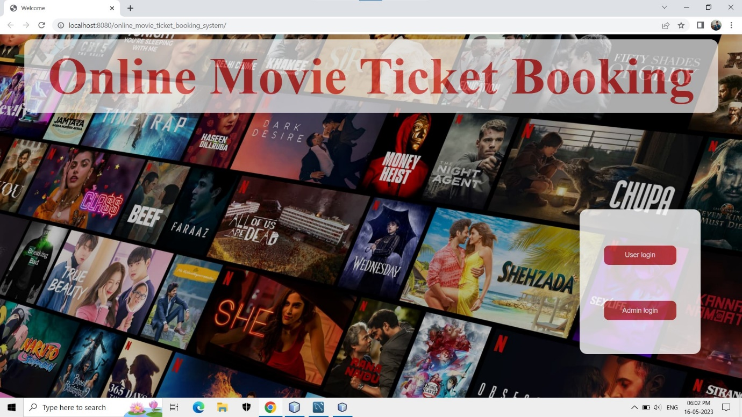

**Register: -**

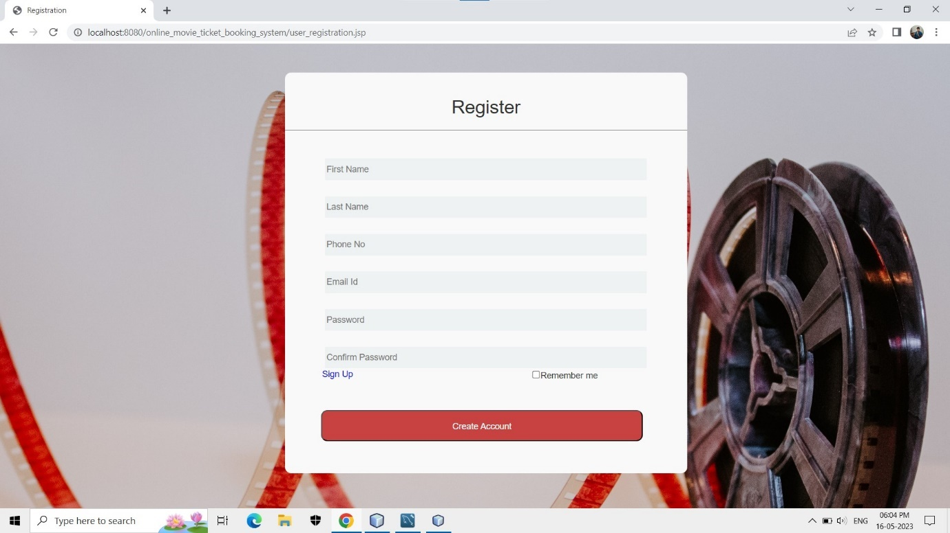

**Login: -**

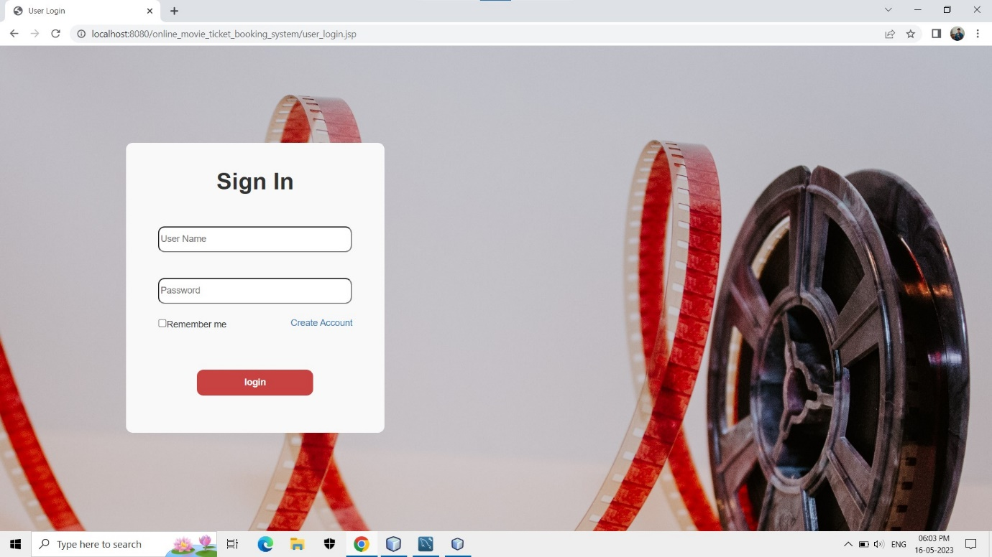

**Home: -**

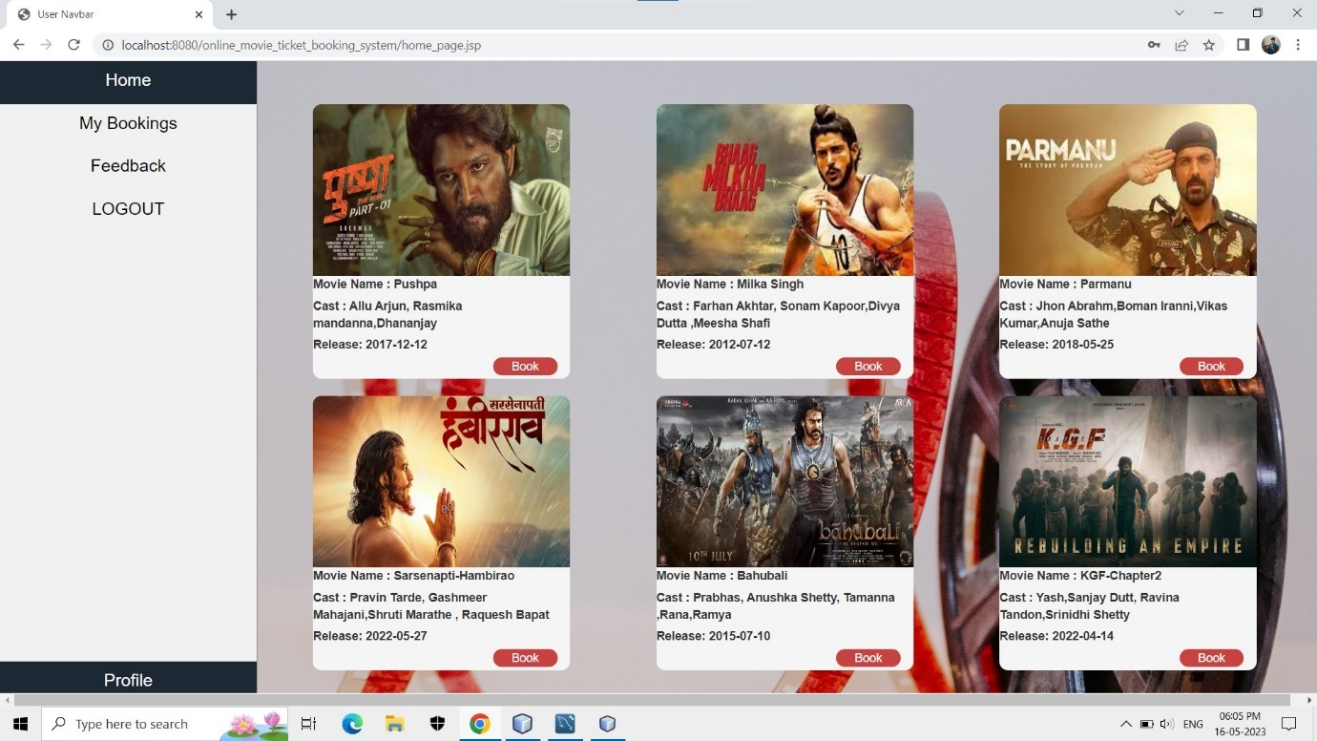

**Booking Page: -**

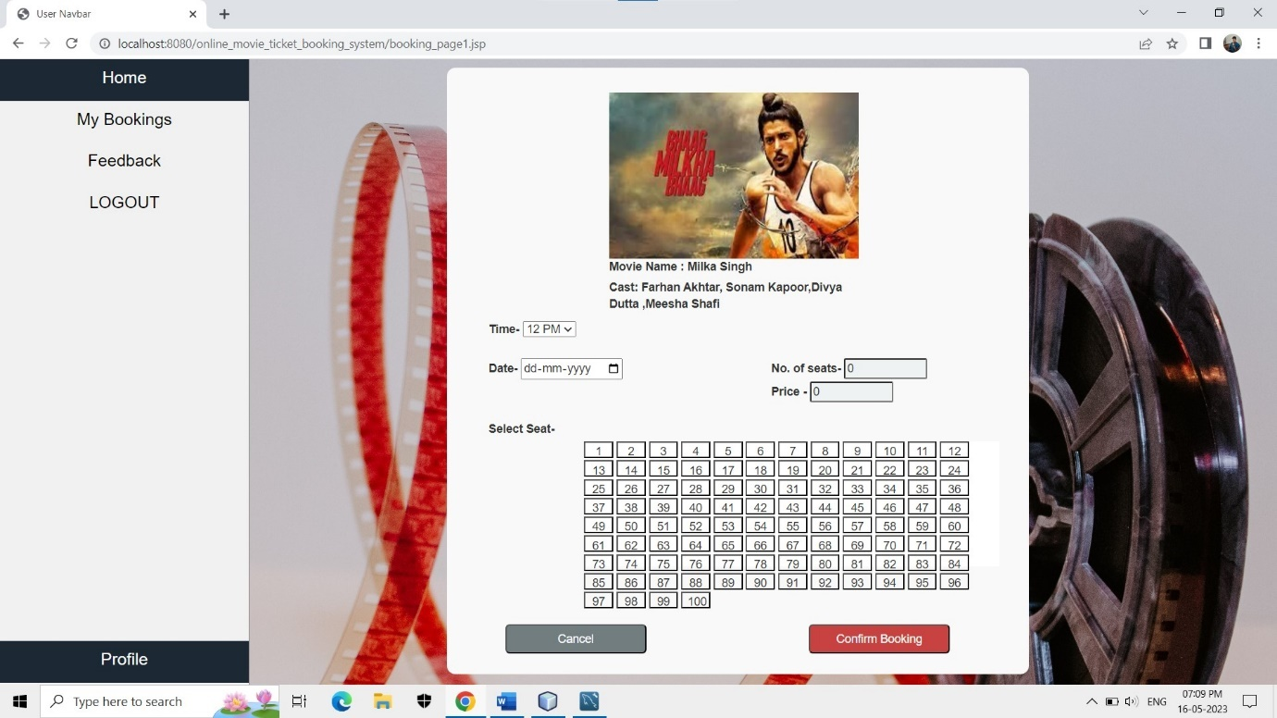

**Payment Page: -**

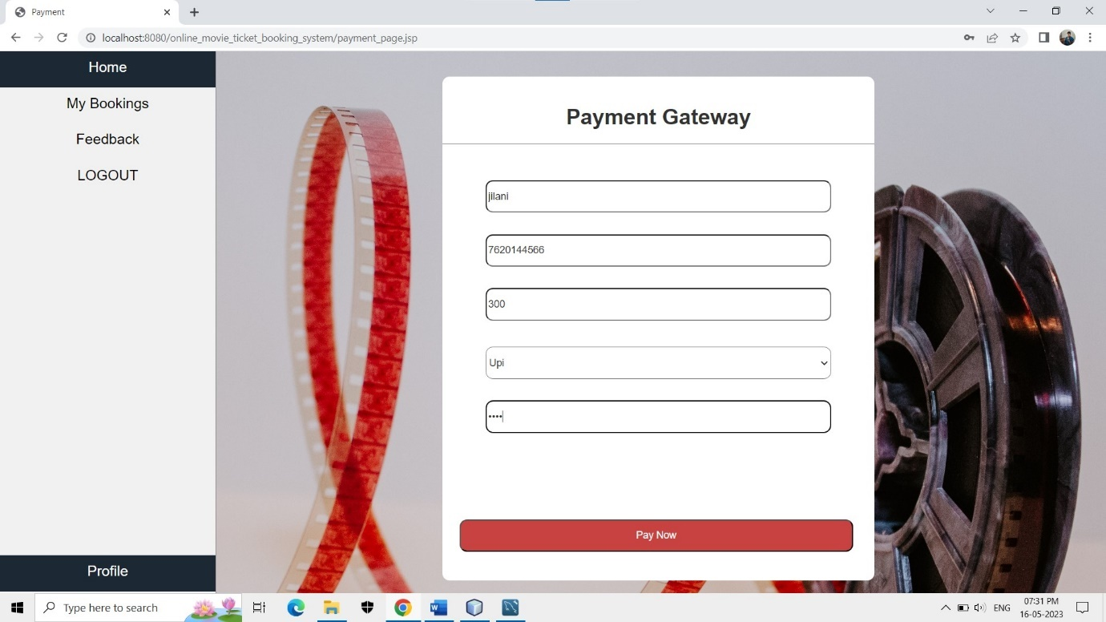

**My Booking: -**

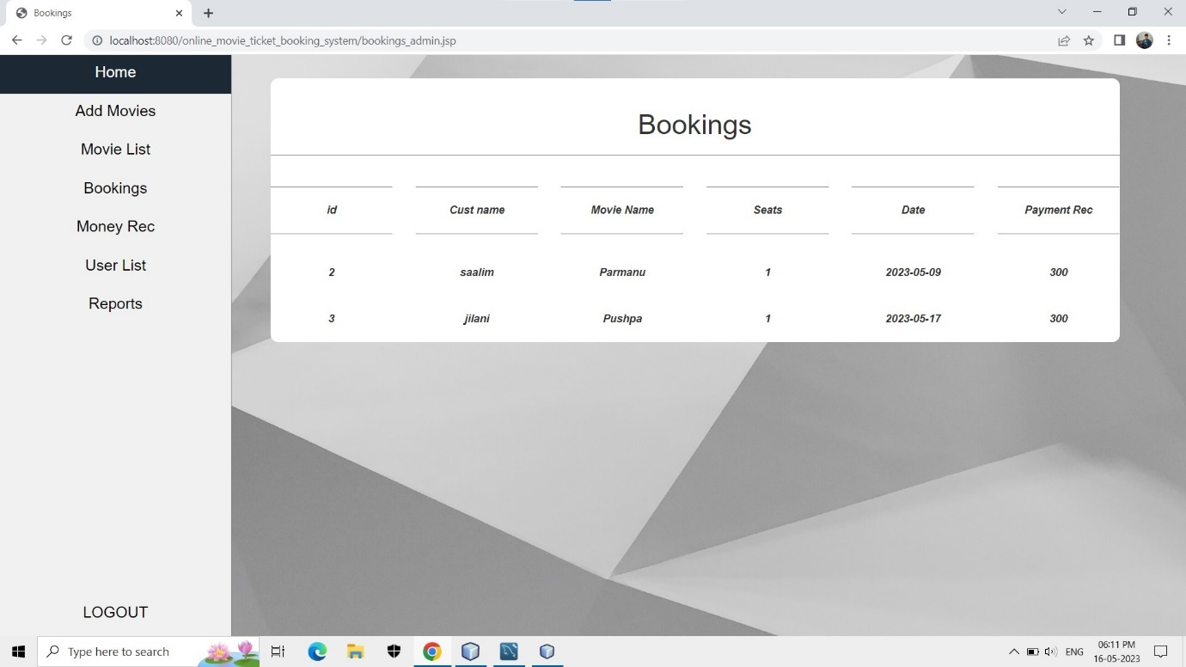

**Feedback Page :-**

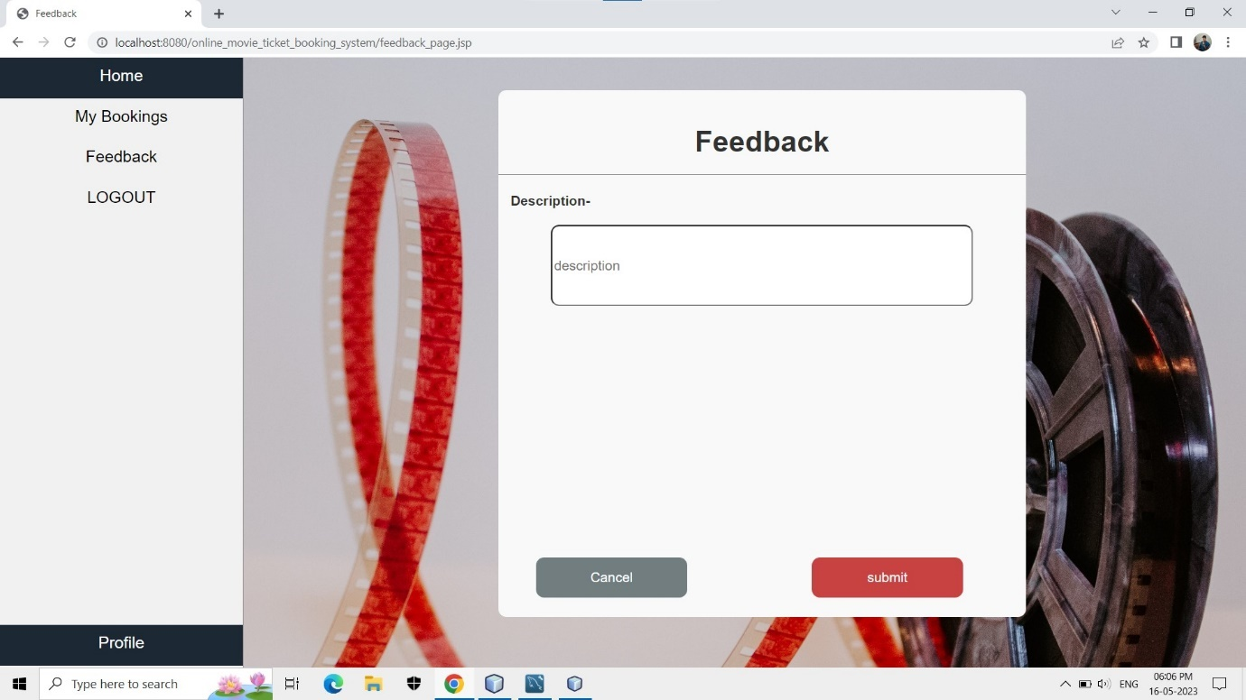

**Admin Login :-**

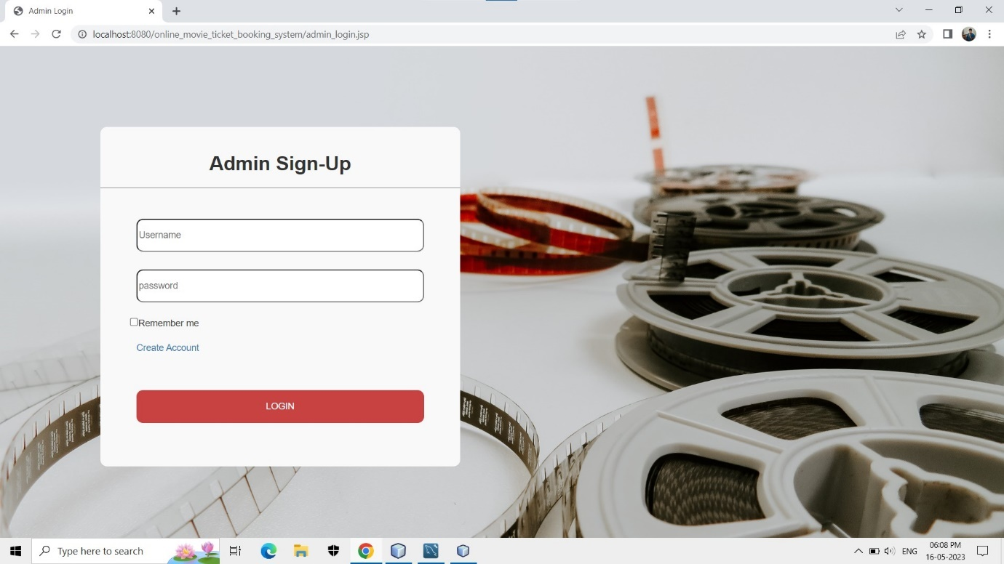

**Admin Registration: -**

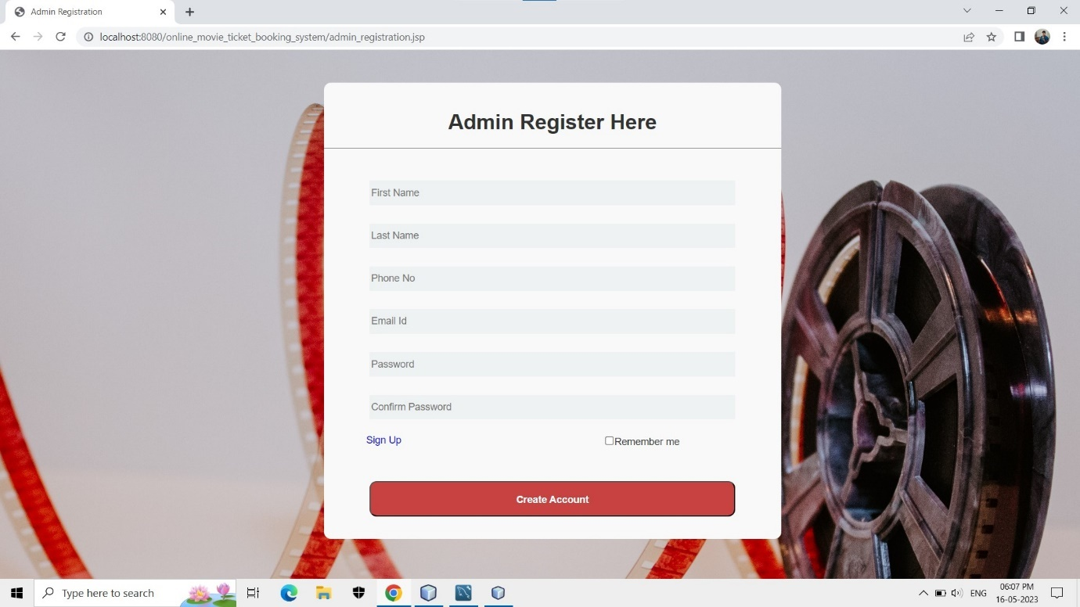

**Admin Home: -**

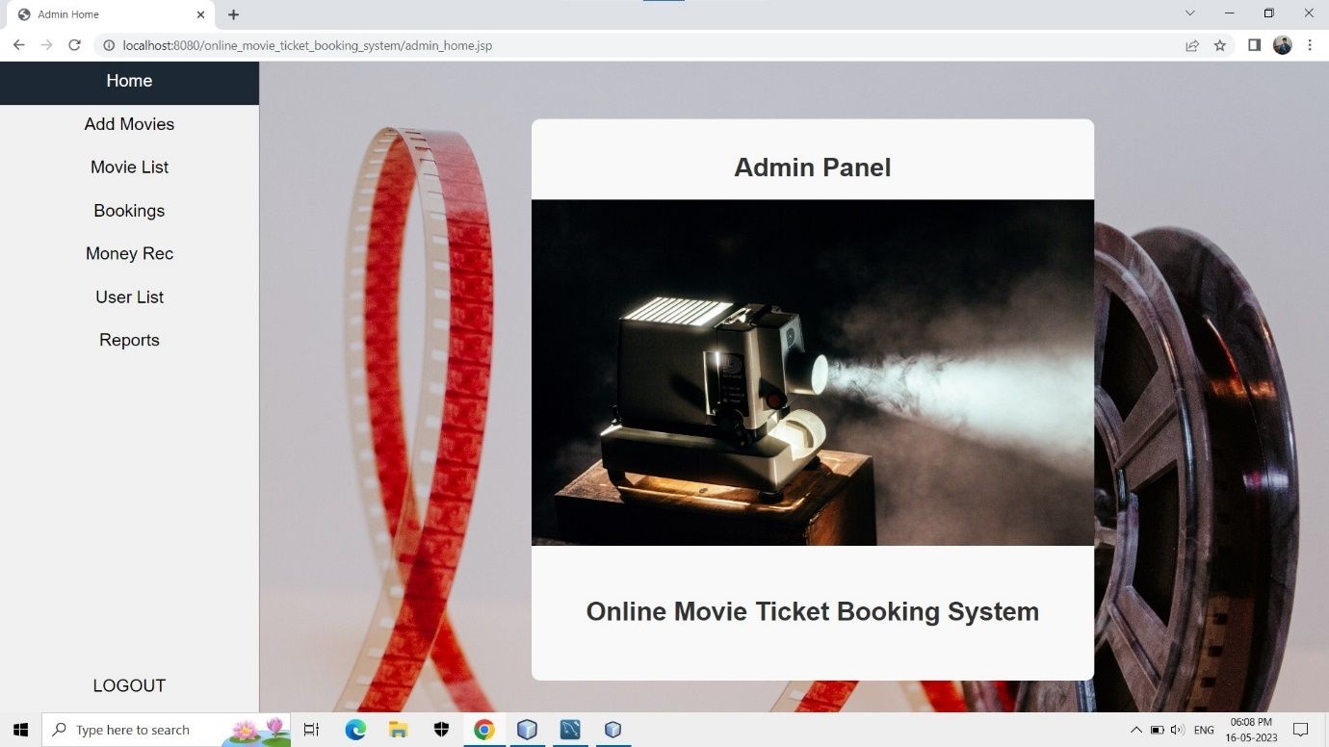

**Add Movie: -**

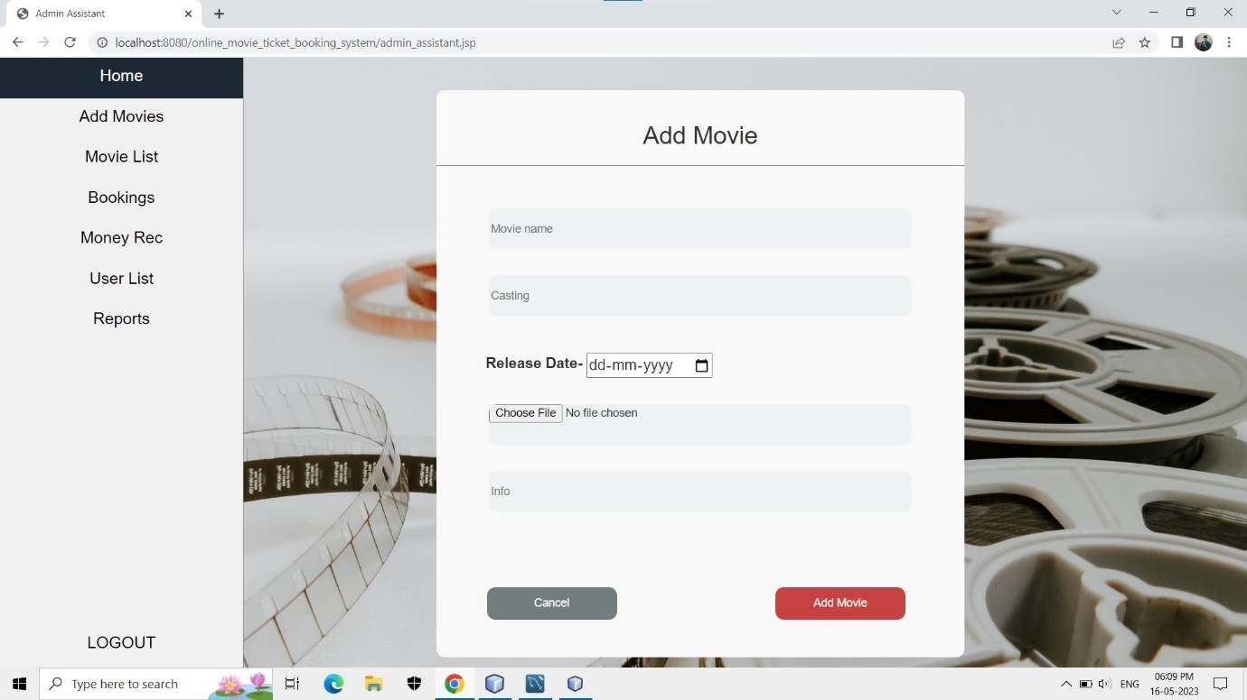

**Movie List: -**

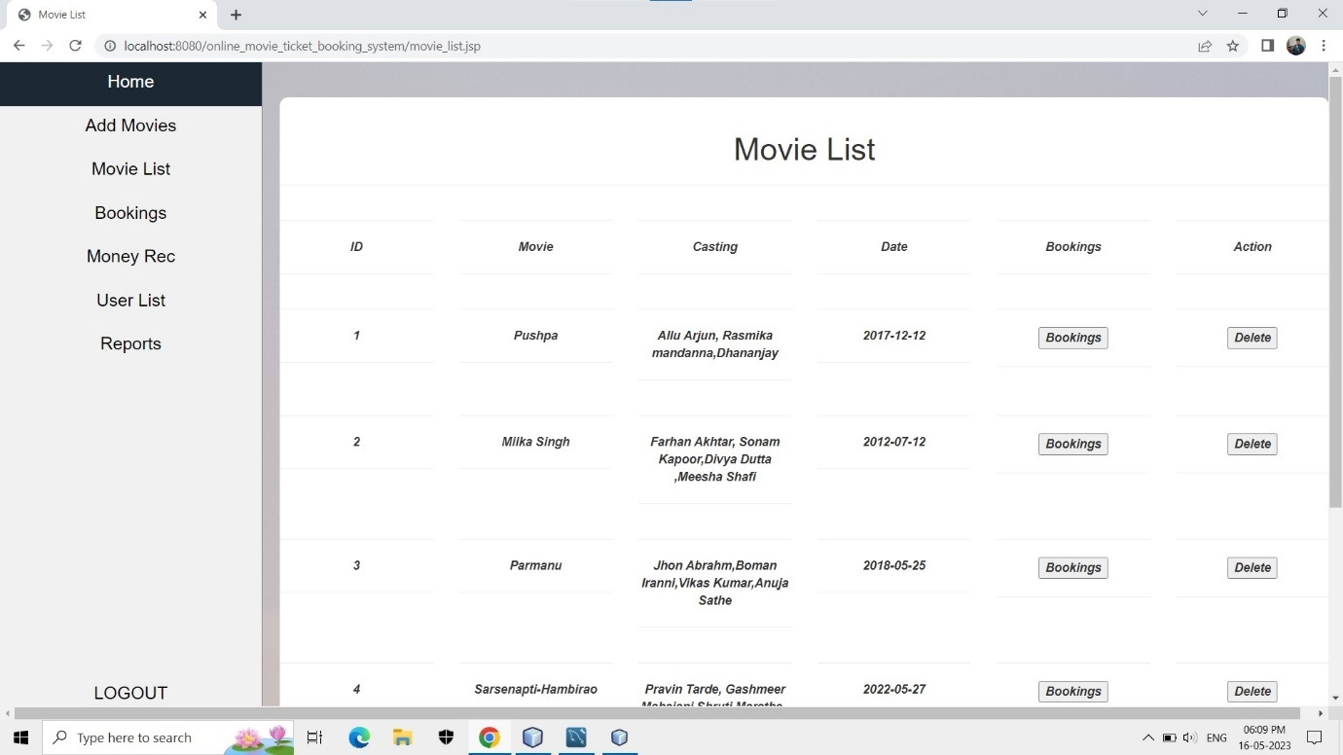

**Booking’s: -**



**Money Rec.: -**

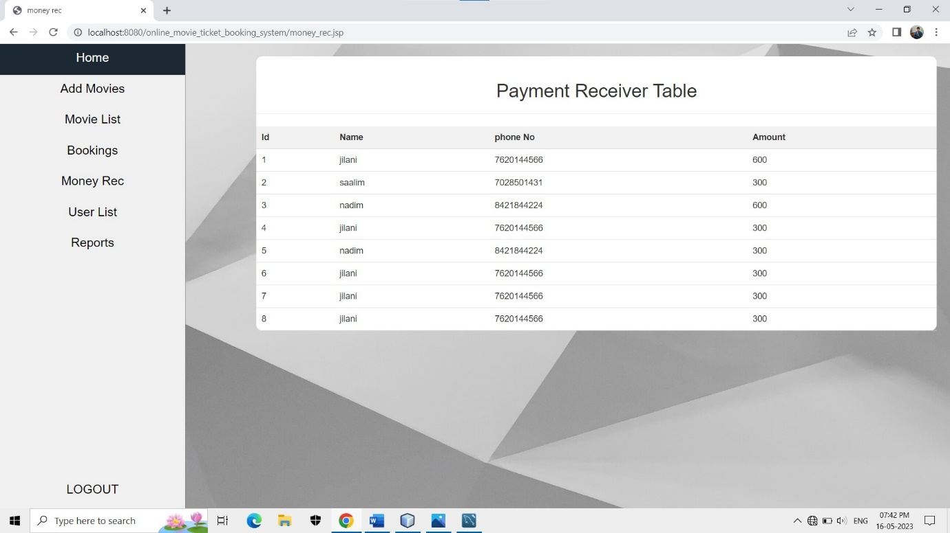

**User List: -**

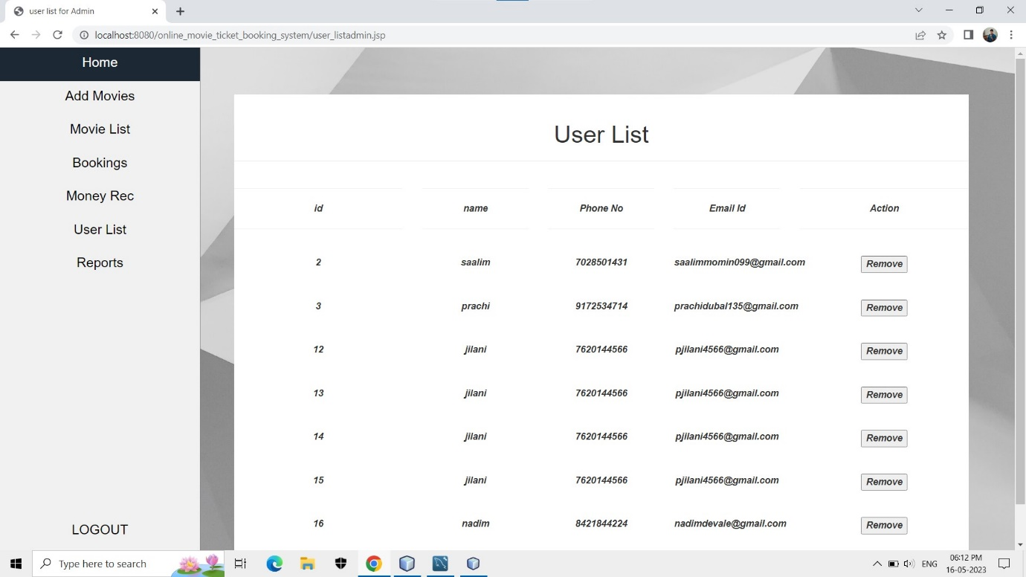

**Report Page’s: -**

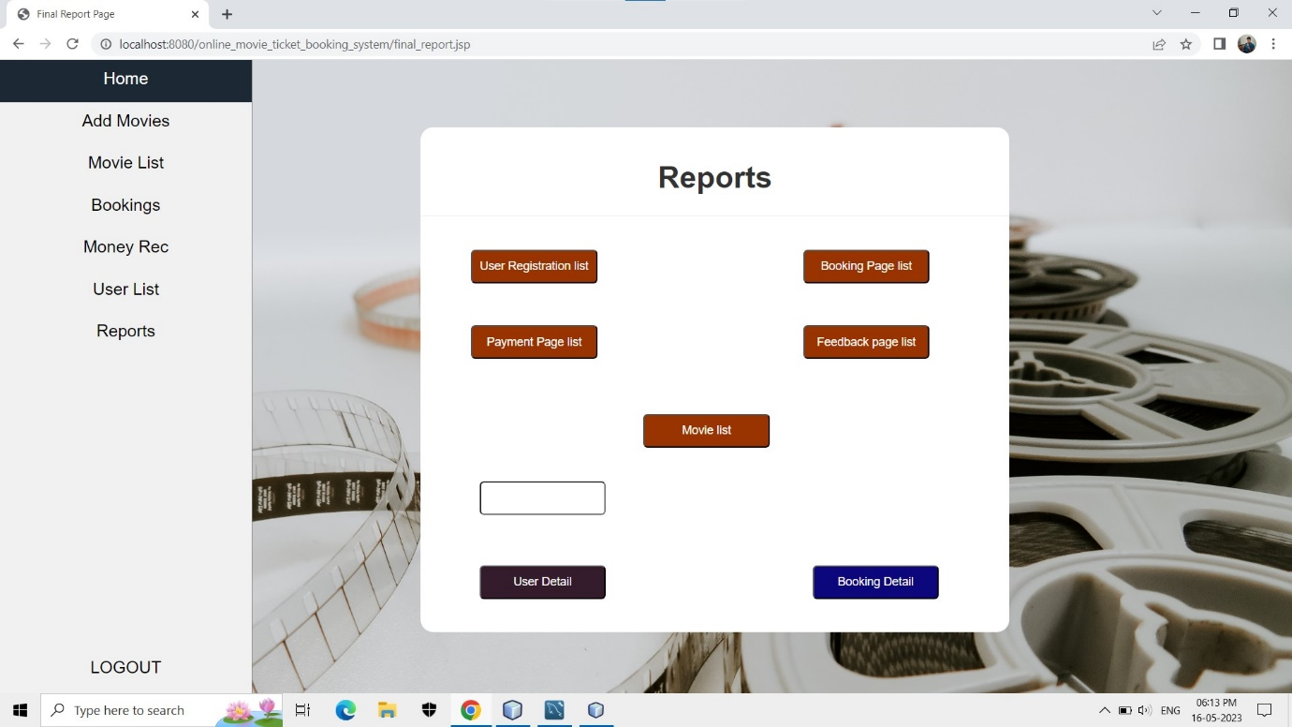

**User Registration-**

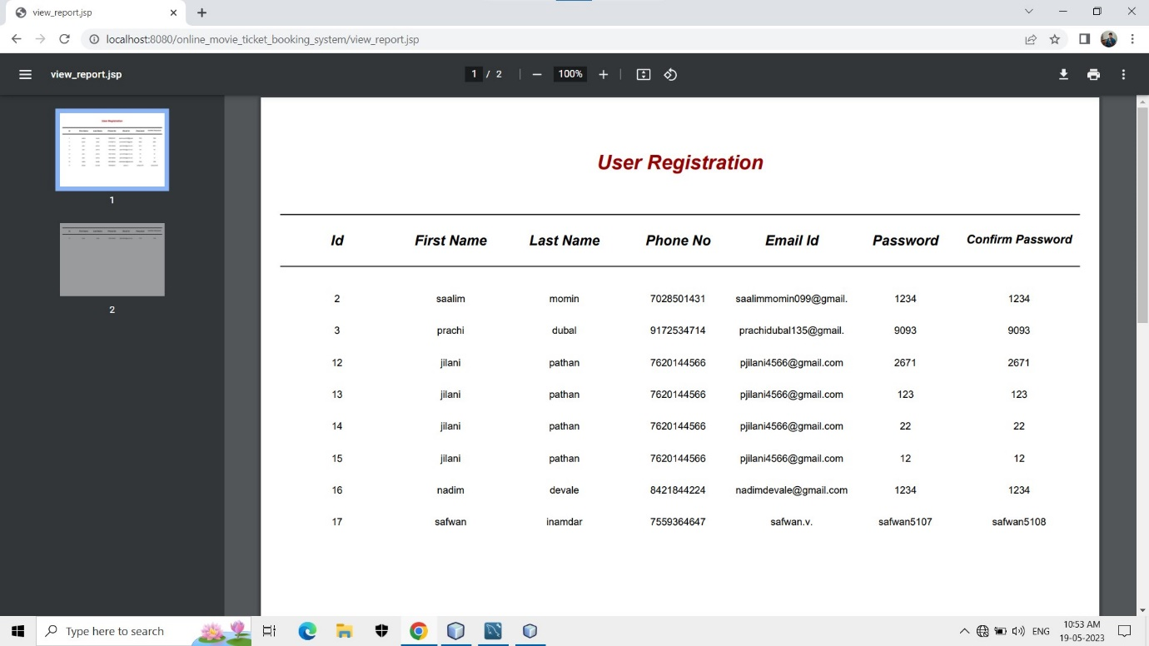

**Booking list-**

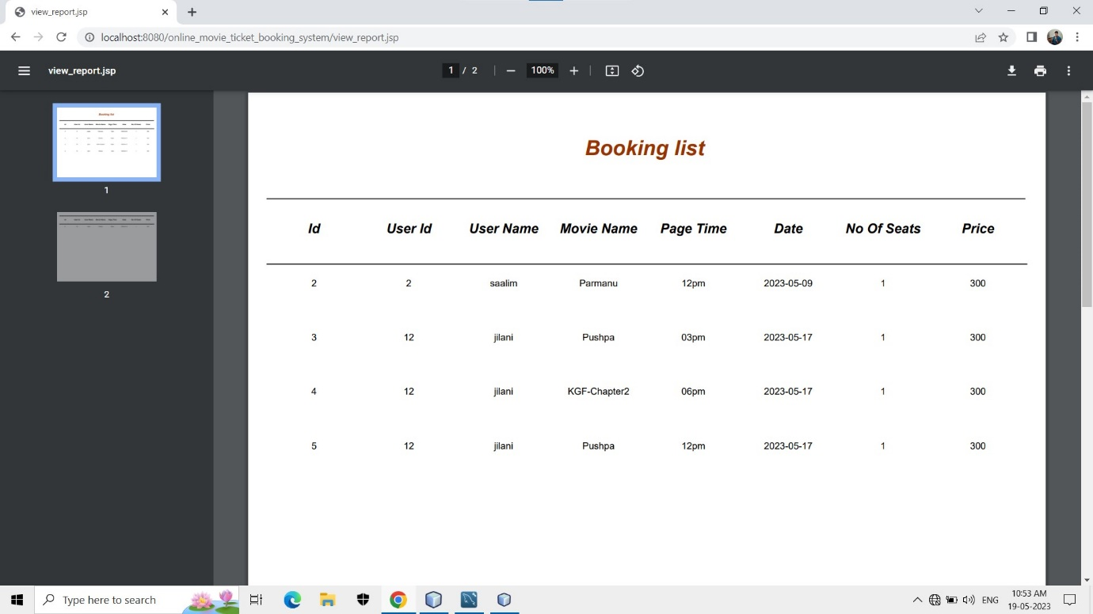

**Payment Page-**

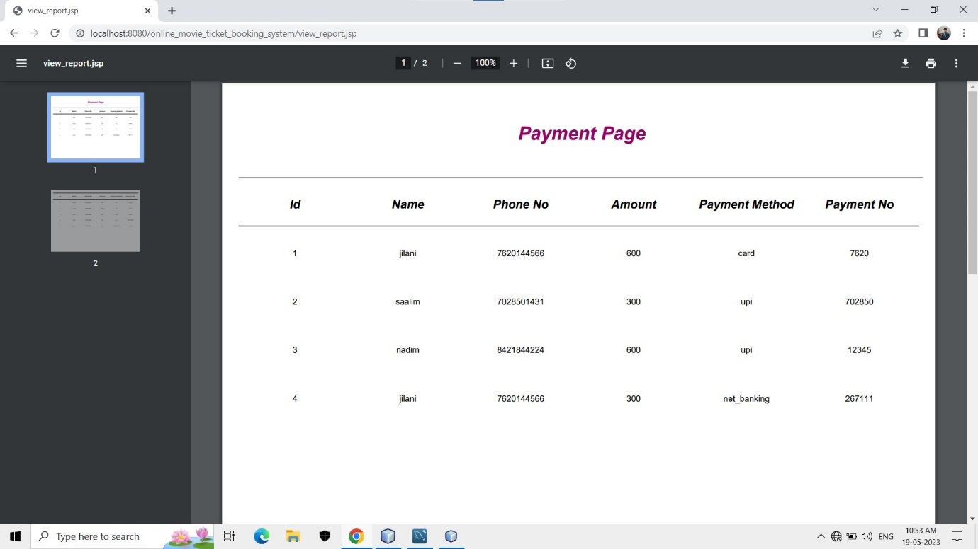

**Feedback page -**

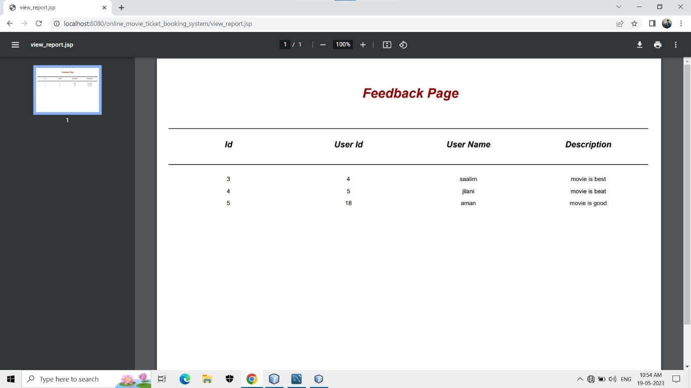

**Movie list-**

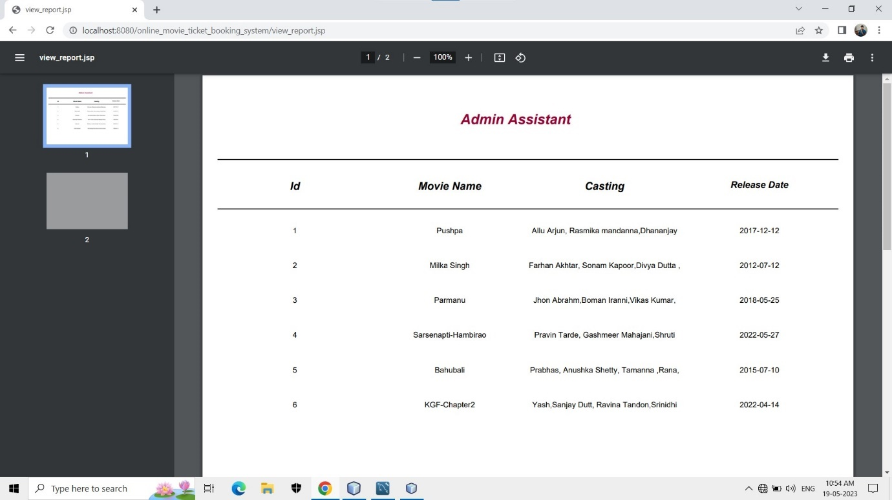

**CHAPTER-6**

Future enhancements

**FUTURE ENHANCEMENTS**

There are several potential future enhancements that could be implemented in an online movie ticket booking system.

* Personalized Recommendations: Implement a recommendation engine that analyzes users' viewing history, preferences, and ratings to provide personalized movie recommendations. This can enhance the user experience by suggesting relevant movies and increasing engagement. Made statement of the aims and objectives of the project.
* Real-Time Updates and Notifications: Implement real-time updates and notifications to keep users informed about ticket availability, showtime changes, special offers, and upcoming releases. This can help users stay engaged and informed about the latest movie-related updates.
* Dynamic Seat Selection: Develop a dynamic seat selection feature that allows users to see the availability of seats in real-time. This can include interactive seat maps and the ability to select seats based on preferences like proximity to the screen or aisle. We understand the problem domain and produce a model of the system, which describes operations that can be performed on the system.
* Integrated Reviews and Ratings: Allow users to rate and review movies directly within the ticket booking system. This can provide valuable feedback to other users and help them make informed decisions about which movies to watch.

Remember, these enhancements should be based on user needs and market research. Prioritize features that will improve the overall user experience and drive customer satisfaction.

**CHAPTER-7**

Limitations

**Limitations & Suggestions**

Every system has some limitations and because of limitation there is a occurrence of suggestion here we discuss the limitation suggestion of our system “Online Movie Ticket Booking System”.

**Limitations: -**

1. This System runs only windows platform
2. This System is not Single user
3. Deleted record cannot be recovered

**Suggestions: -**

1. The user should enter data correctly
2. While getting reports check whether printer is ready or not
3. To start this system, you have to enter correct password
4. Follow the user manual whenever necessary
5. The user knows detail information about the system

**CHAPTER-8**

Conclusion

**CONCLUSION**

Our project is only a humble venture to satisfy the needs to manage their project work. Several user-friendly coding have also adopted.

* A description of the background and context of the project and its relation to work already done in the area.
* Made statement of the aims and objectives of the project.
* The description of Purpose. Scope, and applicability
* We define the problem on which we are working in the project.
* We describe the requirement Specifications of the system and the actions that can be done on these things.
* We understand the problem domain and produce a model of the system, which describes operations that can be performed on the system.
* We included features and operations in detail, including screen layouts

We designed user interface and security issues related to system. Finally, the system is implemented and tested according to test cases

BIBLIOGRAPHY

**BIBLIOGRAPHY**

* Kumar, R., & Joshi, A. (2017). Design and implementation of online movie ticket booking system using Java and MySQL. International Journal of Computer Applications.
* Shukla, V., & Verma, N. (2018). Development of an online movie ticket booking system using Java and MySQL. International Journal of Advanced Research in Computer Science.
* Agarwal, S., & Gupta, M. (2019). Implementation of online movie ticket booking system using Java and MySQL. International Journal of Scientific Research in Computer Science, Engineering and Information Technology.

**Website’s:**

[**www.wikipedia.com**](http://www.wikipedia.com)

[**www.**](http://www.gogle.com)[**https://www.google.co.in/**](https://www.google.co.in/)

[**www.javatpoint**](http://www.javatpoint)